EOC ASSIGNMENT – 2

MTIHIN DEV A

***4. Write a hack assembly language program to swap two values using a temporary variable.***

Ans:

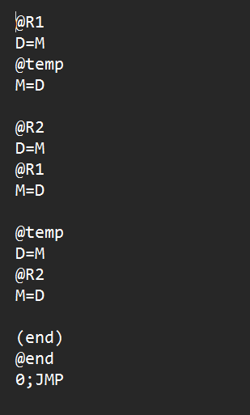

Explanation:

The code starts by loading the value from memory location R1 into a register D. Then, it stores the value in a temporary memory location called "temp" by using the store instruction "M=D".

Next, the code loads the value from memory location R2 into register D. Then, it stores the value in memory location R1 by using the store instruction "M=D".

After that, the code loads the value from the temporary memory location "temp" into register D. Then, it stores the value in memory location R2 by using the store instruction "M=D".

Finally, the code defines the "end" label and jumps to it using an unconditional jump instruction, "0;JMP". The "end" label doesn't contain any instruction and simply serves as a way to exit the loop and terminate the program.

____________________________________________________________

***5. Write and execute a hack assembly language program to implement the sum of 50 numbers starting from 10. (Eg: 10+11+12+......+50)***

Ans:

Explanation:

This code performs a sum of numbers from 1 to a given number 'n' and then subtracts the resulting sum from 45.

The code starts by initializing some registers with values. It then enters into a loop labelled "LOOP" which continues until the value of "i" becomes greater than the value of "n". Inside the loop, it adds the current value of "i" to the sum and increments "i" by 1.

When the loop ends, the code subtracts the current sum value from 45 and stores the result in memory location R1.

Finally, the code defines the "END" label and jumps to it using an unconditional jump instruction, "0;JMP". The "END" label doesn't contain any instruction and simply serves as a way to exit the loop and terminate the program.

